**Federated CvM**

**Huấn luyện theo %non-iid**

|  |  |  |  |  |  |  |  |  |  |  |  |
| --- | --- | --- | --- | --- | --- | --- | --- | --- | --- | --- | --- |
|  | %non-iid = 0 | 10 | 20 | 30 | 40 | 50 | 60 | 70 | 80 | 90 | 100 |
| Acc | 0.9918 | 0.9917 | 0.9911 | 0.9913 | 0.9915 | 0.9912 | 0.9915 | 0.9895 | 0.9857 | 0.9468 | 0.1512 |
| Precision | 0.9918 | 0.9917 | 1.0 | 0.9913 | 0.9915 | 0.9912 | 0.9915 | 0.9895 | 0.9857 | 0.996 | 1.0 |
| Recall | 0.9918 | 0.9917 | 0.9911 | 0.9913 | 0.9915 | 0.9912 | 0.9915 | 0.9895 | 0.9857 | 0.9468 | 0.1512 |
| F1-Score | 0.9918 | 0.9917 | 0.9911 | 0.9913 | 0.9915 | 0.9912 | 0.9915 | 0.9895 | 0.9857 | 0.9468 | 0.2503 |

'accuracy0': [(0, 0.1017), (1, 0.9477), (2, 0.9682), (3, 0.9766), (4, 0.9816), (5, 0.9827), (6, 0.9841), (7, 0.9848), (8, 0.9851), (9, 0.9876), (10, 0.9888), (11, 0.9888), (12, 0.9887), (13, 0.9882), (14, 0.99), (15, 0.9885), (16, 0.99), (17, 0.9899), (18, 0.9903), (19, 0.9896), (20, 0.9904), (21, 0.9906), (22, 0.9902), (23, 0.9905), (24, 0.9908), (25, 0.9901), (26, 0.9904), (27, 0.991), (28, 0.9906), (29, 0.9905), (30, 0.9916), (31, 0.9909), (32, 0.9916), (33, 0.9908), (34, 0.9912), (35, 0.9918), (36, 0.9914), (37, 0.9915), (38, 0.9909), (39, 0.9908), (40, 0.9911), (41, 0.9914), (42, 0.9905), (43, 0.9914), (44, 0.9915), (45, 0.9915), (46, 0.9913), (47, 0.9912), (48, 0.9911), (49, 0.9913), (50, 0.9911)]

'accuracy10': [(0, 0.1241), (1, 0.9408), (2, 0.9659), (3, 0.9763), (4, 0.9785), (5, 0.9826), (6, 0.9837), (7, 0.9847), (8, 0.9856), (9, 0.9874), (10, 0.9882), (11, 0.9871), (12, 0.9888), (13, 0.9884), (14, 0.9894), (15, 0.9882), (16, 0.9884), (17, 0.9892), (18, 0.9892), (19, 0.9888), (20, 0.99), (21, 0.9906), (22, 0.9902), (23, 0.9901), (24, 0.9903), (25, 0.9906), (26, 0.9902), (27, 0.9903), (28, 0.9896), (29, 0.9902), (30, 0.9904), (31, 0.9911), (32, 0.9908), (33, 0.9907), (34, 0.9909), (35, 0.9901), (36, 0.9902), (37, 0.9908), (38, 0.991), (39, 0.9899), (40, 0.9904), (41, 0.9903), (42, 0.9905), (43, 0.9906), (44, 0.9915), (45, 0.9905), (46, 0.9913), (47, 0.9903), (48, 0.9903), (49, 0.9917), (50, 0.9911)]

'accuracy50': [(0, 0.1175), (1, 0.8984), (2, 0.9607), (3, 0.9708), (4, 0.9732), (5, 0.9776), (6, 0.9792), (7, 0.9827), (8, 0.9835), (9, 0.9843), (10, 0.985), (11, 0.9865), (12, 0.9855), (13, 0.9854), (14, 0.9859), (15, 0.9878), (16, 0.9885), (17, 0.9876), (18, 0.9888), (19, 0.9894), (20, 0.9883), (21, 0.9884), (22, 0.9885), (23, 0.9894), (24, 0.9886), (25, 0.9898), (26, 0.9895), (27, 0.9908), (28, 0.9903), (29, 0.9901), (30, 0.9905), (31, 0.9905), (32, 0.9888), (33, 0.9902), (34, 0.9903), (35, 0.991), (36, 0.9903), (37, 0.9897), (38, 0.991), (39, 0.991), (40, 0.991), (41, 0.9902), (42, 0.9906), (43, 0.9898), (44, 0.99), (45, 0.9902), (46, 0.9908), (47, 0.9912), (48, 0.9912), (49, 0.9904), (50, 0.9901)]

'accuracy90': [(0, 0.0544), (1, 0.1071), (2, 0.1199), (3, 0.2644), (4, 0.2435), (5, 0.1839), (6, 0.1825), (7, 0.3292), (8, 0.4258), (9, 0.3701), (10, 0.2493), (11, 0.5501), (12, 0.617), (13, 0.6961), (14, 0.7194), (15, 0.7499), (16, 0.7969), (17, 0.8385), (18, 0.7955), (19, 0.8185), (20, 0.8494), (21, 0.8647), (22, 0.8558), (23, 0.8695), (24, 0.8889), (25, 0.8877), (26, 0.909), (27, 0.9085), (28, 0.9017), (29, 0.8704), (30, 0.9103), (31, 0.9131), (32, 0.8675), (33, 0.897), (34, 0.8962), (35, 0.9042), (36, 0.9034), (37, 0.9105), (38, 0.9081), (39, 0.904), (40, 0.9014), (41, 0.9269), (42, 0.9231), (43, 0.9093), (44, 0.9431), (45, 0.9295), (46, 0.9239), (47, 0.9338), (48, 0.9468), (49, 0.9237), (50, 0.9426)]

'accuracy`100': [(0, 0.1512), (1, 0.1028), (2, 0.098), (3, 0.0974), (4, 0.0974), (5, 0.101), (6, 0.0974), (7, 0.098), (8, 0.1028), (9, 0.0892), (10, 0.1032), (11, 0.0982), (12, 0.1032), (13, 0.1028), (14, 0.1009), (15, 0.1135), (16, 0.1009), (17, 0.1028), (18, 0.1135), (19, 0.098), (20, 0.0892), (21, 0.101), (22, 0.0974), (23, 0.098), (24, 0.0974), (25, 0.098), (26, 0.101), (27, 0.0892), (28, 0.0982), (29, 0.1032), (30, 0.1135), (31, 0.101), (32, 0.1135), (33, 0.0982), (34, 0.098), (35, 0.1032), (36, 0.1028), (37, 0.0958), (38, 0.1009), (39, 0.0974), (40, 0.1028), (41, 0.0974), (42, 0.0982), (43, 0.101), (44, 0.0958), (45, 0.098), (46, 0.0892), (47, 0.1009), (48, 0.1135), (49, 0.1009), (50, 0.1135)]

**Huấn luyện theo alpha**

**Alpha = 50**

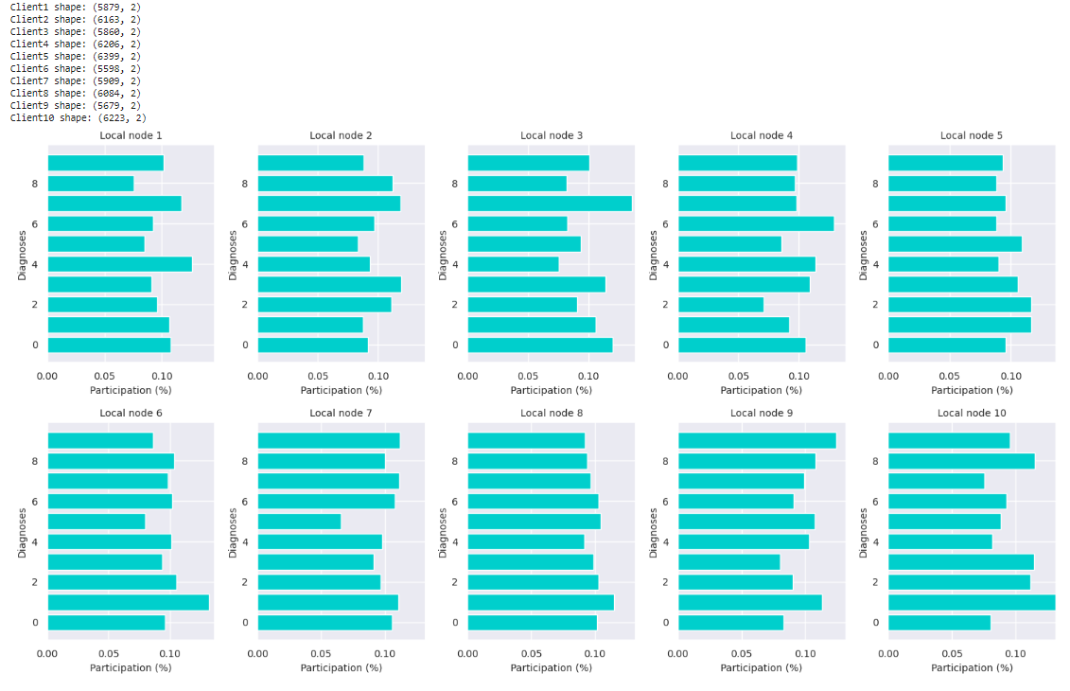

Test: commun_round: 50 | global_acc: 0.9919 | global_pre: 0.9919084785581014 | global_rec: 0.9919 | global_f1s: 0.9919026047907548

'accuracy': [(0, 0.108), (1, 0.9406), (2, 0.9712), (3, 0.9764), (4, 0.9821), (5, 0.982), (6, 0.9837), (7, 0.9853), (8, 0.9863), (9, 0.9859), (10, 0.9871), (11, 0.986), (12, 0.9891), (13, 0.9877), (14, 0.9877), (15, 0.9891), (16, 0.9887), (17, 0.9885), (18, 0.99), (19, 0.9892), (20, 0.9891), (21, 0.9893), (22, 0.99), (23, 0.9896), (24, 0.9901), (25, 0.99), (26, 0.9902), (27, 0.9911), (28, 0.9906), (29, 0.9903), (30, 0.99), (31, 0.9904), (32, 0.9909), (33, 0.9908), (34, 0.9902), (35, 0.9908), (36, 0.9911), (37, 0.9906), (38, 0.9916), (39, 0.9911), (40, 0.9913), (41, 0.9906), (42, 0.9915), (43, 0.9919), (44, 0.9914), (45, 0.9919), (46, 0.9917), (47, 0.9915), (48, 0.9913), (49, 0.9917), (50, 0.9918)]